K
Krew
APP & SECURITY
OVERVIEW
One identity. Many private worlds.
A factual overview of Krew’s profile spaces, communication features, current security controls, and comparison with WhatsApp and Telegram.
ANDROID APPLICATION • JULY 2026

01 / PRODUCT OVERVIEW
Communication that respects context
Krew combines messaging, calls, social sharing, and passcode-routed profile spaces in one Android experience.

Most messengers organize communication around one account and one main inbox. Krew adds another layer: profile spaces for the different roles a person has in daily life—work, family, friends, study, creator activity, and private communities.
- One phone-based account. Users sign in with their number and access the communication experience from one application.
- Multiple profile spaces. Each space can have its own name, avatar, conversations, circles, and social context.
- Passcode routing. A unique numeric passcode can open its matching profile directly, reducing accidental context switching.
- Complete communication surface. Private and group chat, rich attachments, voice and video calls, stories, posts, reactions, and close-friend circles.
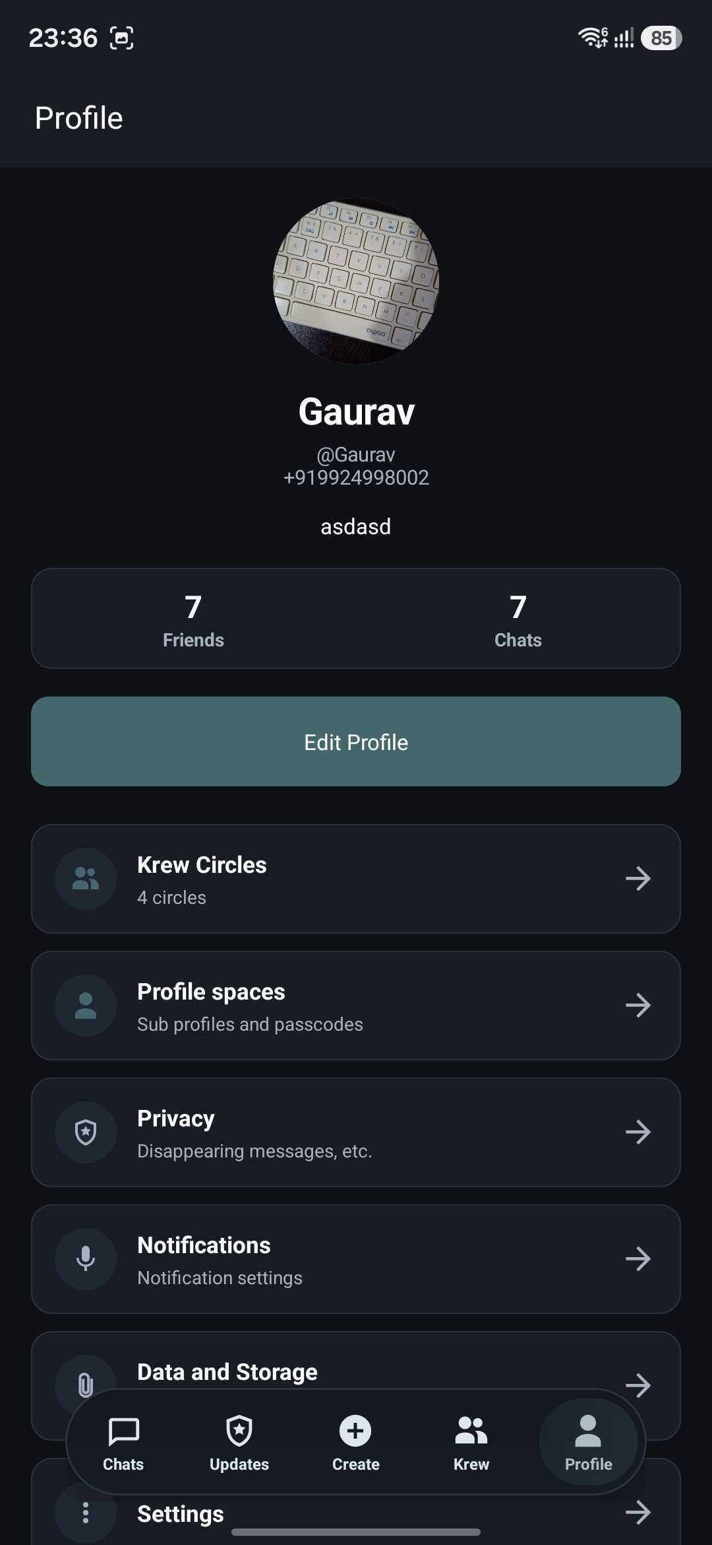
Profile and privacy controls include access to passcode-protected spaces

02 / PROFILE SPACES
Privacy through separation
Krew’s clearest difference is not another hidden chat folder—it is an identity and conversation boundary tied to the passcode used to enter.

01  Main profile control  A main passcode is required before private sub-profiles can be created. | 02  Unique access codes  Each profile uses a distinct 4–12 digit code; duplicates within the account are rejected.
03  Direct routing  The entered passcode opens only the matching profile and its linked chats. | 04  Context-aware activity  Chats, circles, stories, posts, and calls can follow the active identity.
Useful for business users separating customer and personal conversations; students separating family, school, and close friends; creators separating public and private activity; and households where a device is occasionally shared.
 | 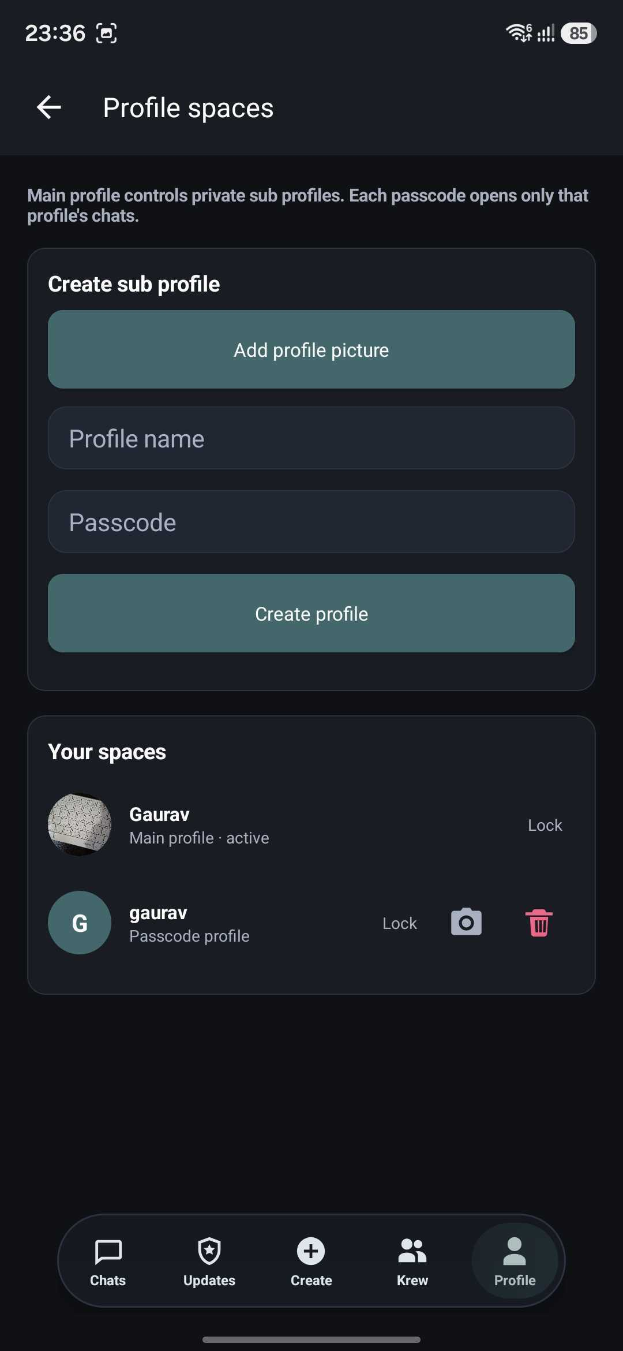
Profile and privacy controls | Create and manage private spaces

03 / CURRENT SECURITY
Security controls implemented today
These statements describe controls found in the reviewed Android and Laravel implementation. They are not a penetration test or independent cryptographic audit.

Profile passcodes | Stored as one-way password hashes rather than readable passcodes.
Stored message text | Encrypted by the Laravel application before database storage and decrypted for authorized delivery.
Voice and video media | Uses WebRTC, whose media channels are protected with DTLS-SRTP transport encryption.
Call recordings | No server-side call recording or call-media archive was found in the reviewed backend.
Device backup | Android application backup is disabled, reducing automatic copying of app data through the platform backup service.
Important distinction
Krew currently provides server-side encryption at rest for message text; that is not the same as end-to-end encryption. Production transport should use HTTPS/WSS, and default E2EE should only be claimed after a mature protocol, device-key design, and independent review are implemented.

03 / CURRENT SECURITY — CALLS
Encrypted call transport in use
Krew’s current 1:1 voice and video experience uses WebRTC media transport.

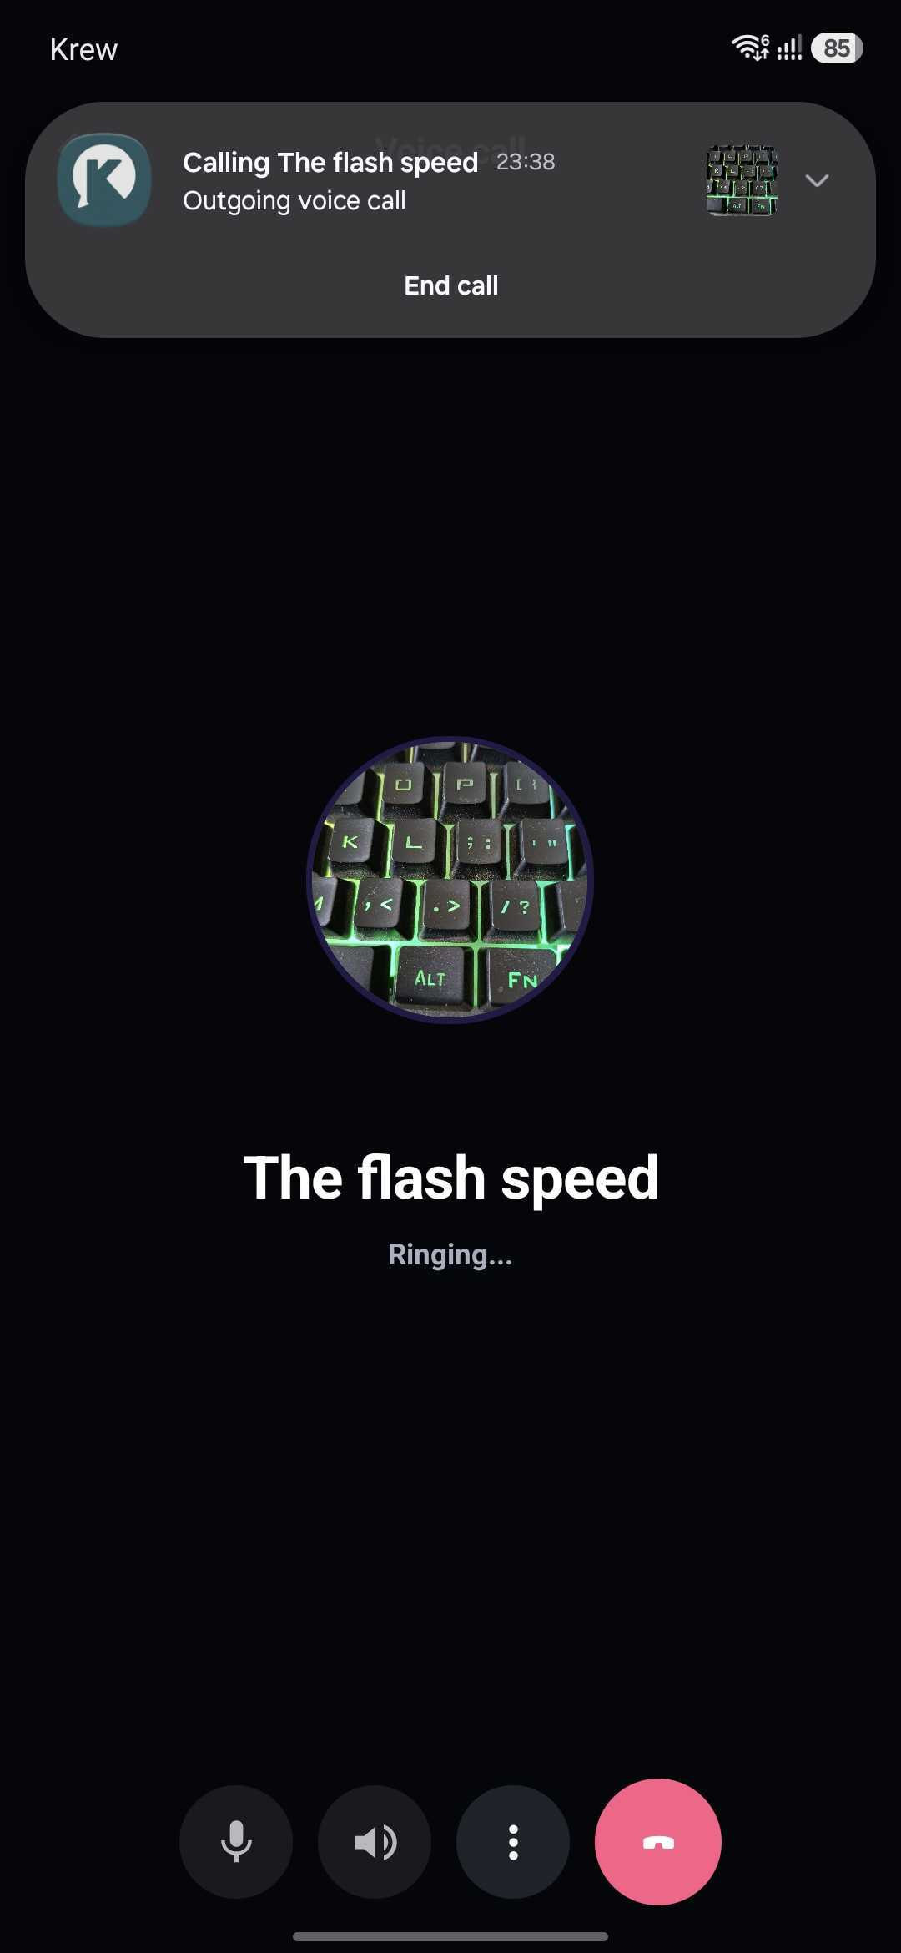 | 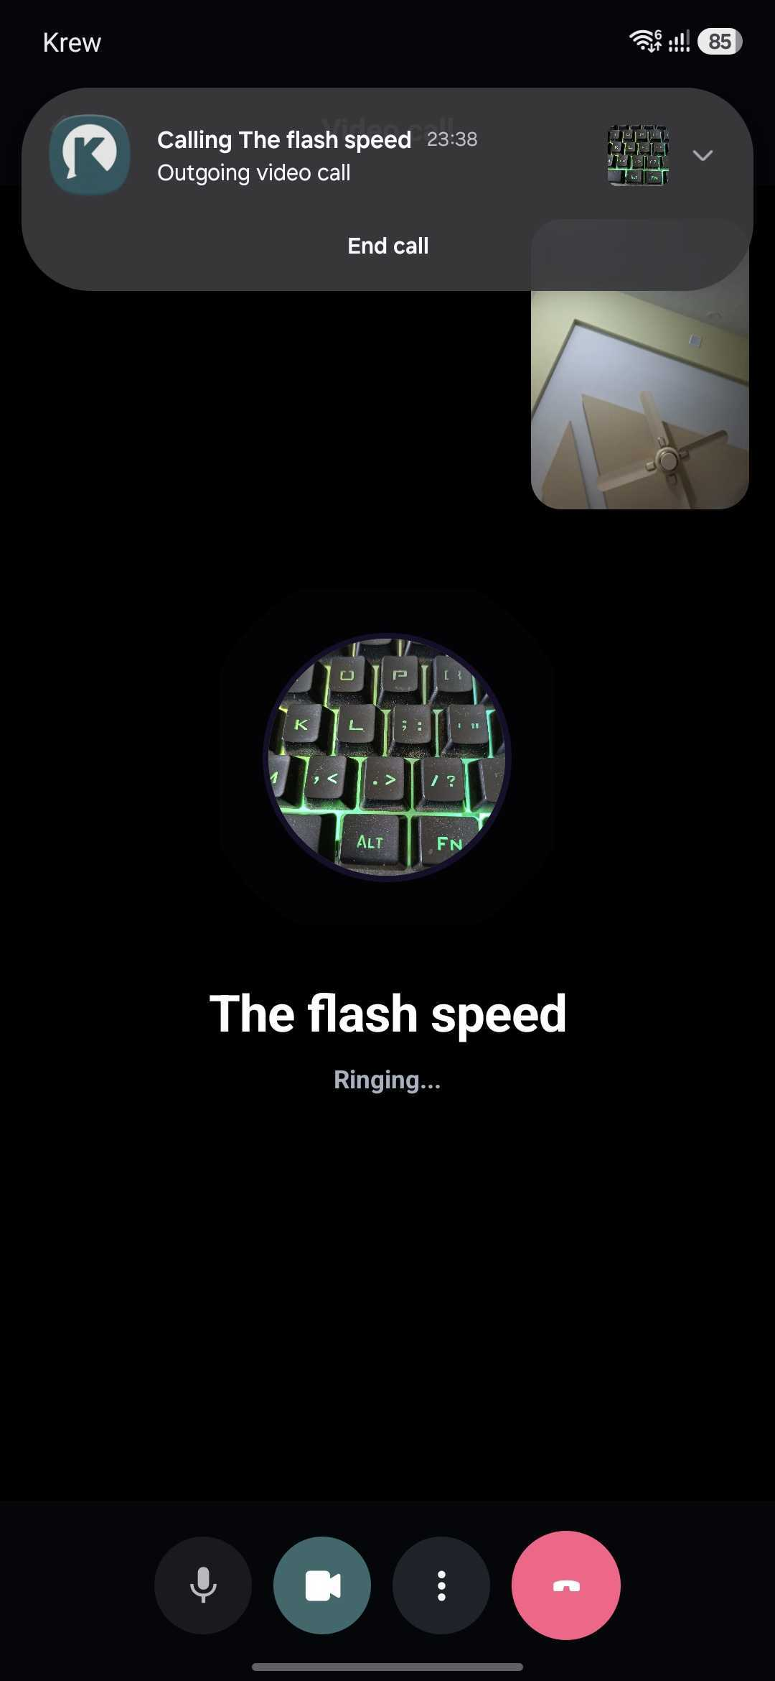
1:1 voice calling | 1:1 video calling

04 / MESSAGING & PRIVACY
A complete private communication workflow
The active profile carries through messaging, sharing, calls, and community activity.

- Private and group messaging. Replies, editing, forwarding, reactions, delivered/read receipts, typing state, and profile-aware membership.
- Rich sharing. Gallery media, camera capture, documents, audio, stickers, emoji, GIFs, current location, and time-limited live location.
- Ephemeral controls. Disappearing messages, disappear-on-exit behavior, chat clearing, and screenshot-event signaling.
- Audience controls. Close friends, circles, profile-scoped stories, posts, replies, comments, and reactions.
- Safety controls. Blocking, presence controls, group administration, chat deletion, and profile-bound access.
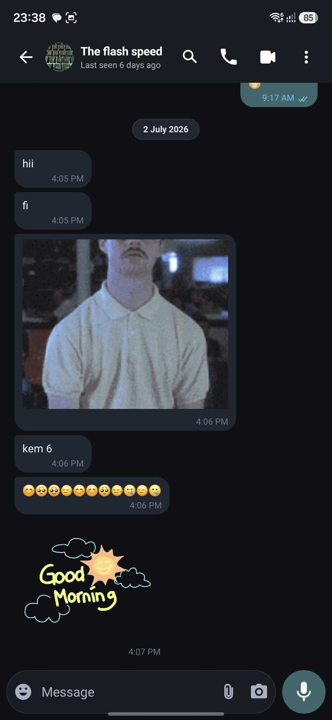 | 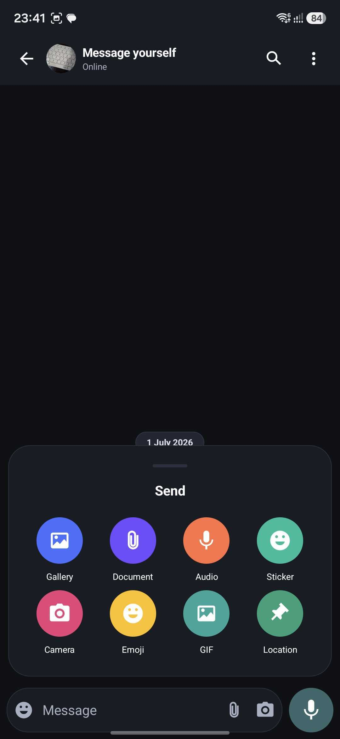
Rich messaging | Attachment and sharing options

05 / COMPARISON
Different strengths, clearly stated
Krew’s advantage is contextual separation. WhatsApp and Telegram retain important strengths in cryptography, scale, and cross-device ecosystems.

Dimension | Krew | WhatsApp | Telegram
Identity | Passcode-routed profile spaces inside one account | Multiple accounts and locked chats | Multiple phone-number accounts and app passcode
Separation | Identity, chats, circles, and social context can be separated by profile | Chat Lock protects selected conversations | Secret Chats are device-specific; Cloud Chats sync
Messages | Server-side encryption at rest; default E2EE not yet claimed | Personal messages use default E2EE | Secret Chats use E2EE; Cloud Chats use client-server encryption
Calls | 1:1 WebRTC encrypted media transport; no server call-media archive found | Calls use default E2EE | Voice and video calls use E2EE
Best fit | One device with several private life or work contexts | Mature default-E2EE messaging and broad reach | Cloud sync, large communities, channels, and extensibility
Why Krew is distinctive
WhatsApp can lock conversations and Telegram can lock the application, but Krew’s profile-space model is designed to change the user’s active identity and associated communication context together. This can provide stronger contextual separation on a shared or single-purpose device; it is a product-access advantage, not a claim of stronger message cryptography.
Comparison reflects official Meta/WhatsApp and Telegram information reviewed 14 July 2026. Features may change by version, platform, or region.

06 / SECURITY DEVELOPMENT
The path to stronger end-to-end protection
Krew can strengthen its privacy position by making security claims testable, documented, and independently reviewed.

01 | Secure production transport Require HTTPS and WSS, remove cleartext allowances where possible, and use authenticated, rotating TURN credentials.

02 | Implement mature messaging E2EE Use a reviewed protocol with forward secrecy, per-device identity keys, secure group key management, and verification.

03 | Design secure device linking and recovery Protect new-device enrollment and recovery without creating a universal server-held decryption path.

04 | Minimize metadata Define retention limits for logs, push payloads, IP information, live location, and operational telemetry.

05 | Review and publish Commission an independent security assessment, document the threat model, and publish a remediation summary.

Security language rule
Use “end-to-end encrypted” only for flows where cryptographic keys are controlled by participant devices and the server cannot read content—and only after implementation and review.

07 / PRODUCT SCREENS
The Krew experience in use
Screens from the current Android application show phone onboarding, friends and circles, profile-based access, rich chat, voice/video calls, and social posting.

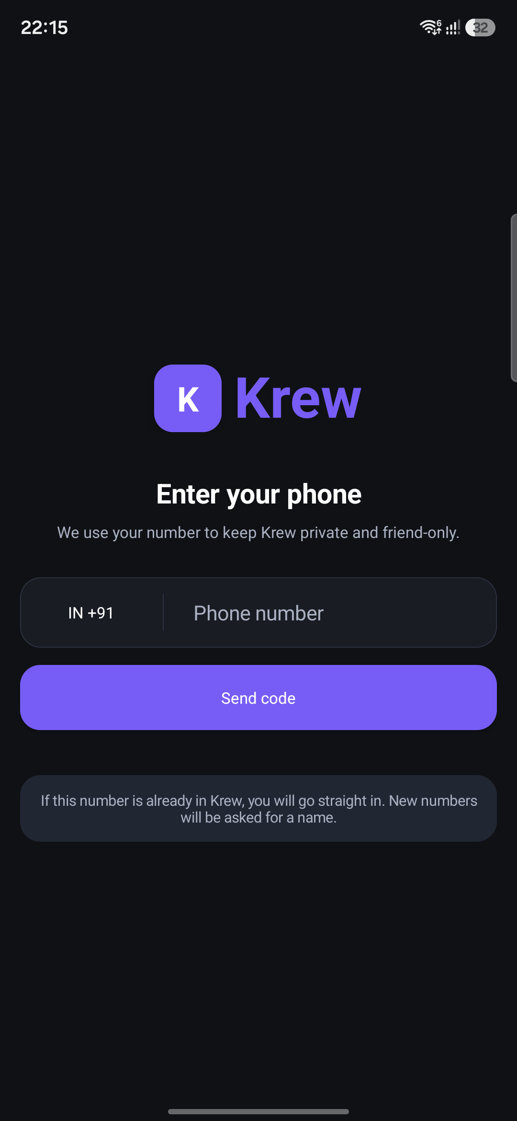 | 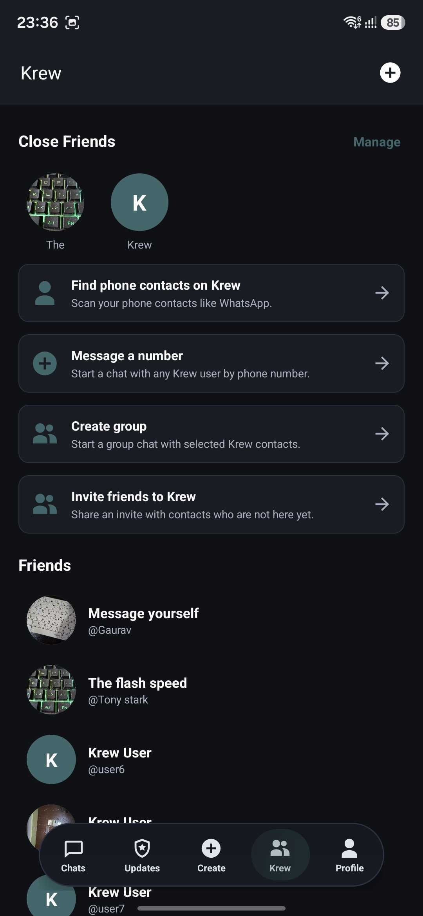
Phone onboarding | Friends and circles

07 / PRODUCT SCREENS — CONTINUED
Messaging and social activity
Rich media conversations and profile-scoped publishing extend the active identity beyond the inbox.

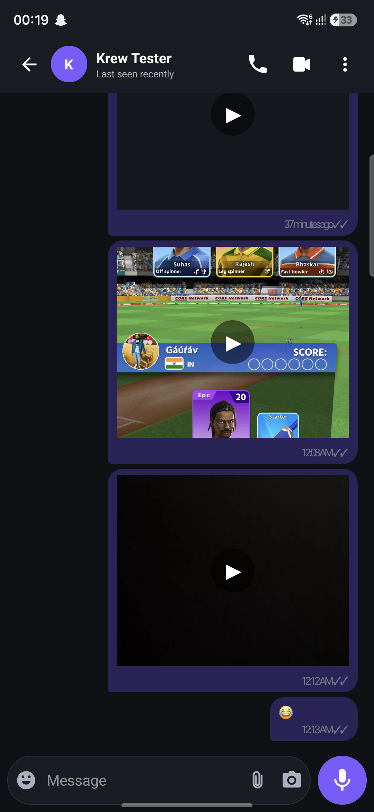 | 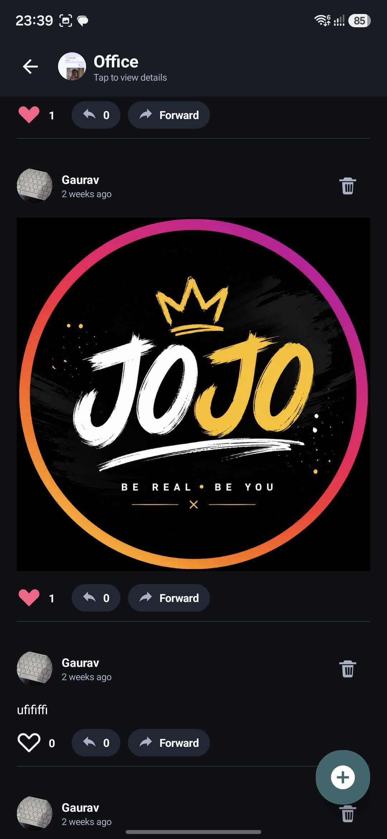
Conversation experience | Profile-scoped social activity

08 / SOURCES & SCOPE
Evidence and accuracy notes
This overview separates implemented controls from future security work so that the product can be described confidently and accurately.

Krew implementation reviewed
Android client source, Laravel API routes and controllers, database migrations, application manifest, and current WebRTC calling implementation in the Krew project repository, reviewed 14 July 2026.
External primary sources
- Meta / WhatsApp privacy features https://about.fb.com/news/2022/08/new-privacy-features-on-whatsapp/
- Meta / WhatsApp Chat Lock https://about.fb.com/news/2023/05/whatsapp-chat-lock/
- Telegram FAQ https://telegram.org/faq
- Telegram privacy policy https://telegram.org/privacy
- IETF WebRTC security architecture https://datatracker.ietf.org/doc/rfc8827/
Scope note
This document is a product and source-code review, not a penetration test, compliance certification, privacy impact assessment, or cryptographic audit. Security and competitor features can change. Public claims should be rechecked before publication and after material architecture changes.

KREW
One identity. Many private worlds.

